No regularization and augmentation

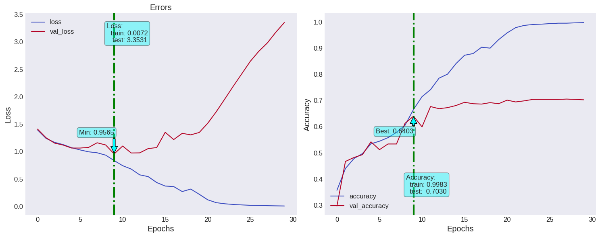

Dropout after maxpool and batch normalized

drop1 = 0.1

drop2 = 0.1

drop3 = 0.2

drop4 = 0.2

drop5 = 0.3

drop6 = 0.3

drop7 = 0.4

drop8 = 0.4

drop9 = 0.5

drop10 = 0.5

model.add(tf.keras.layers.RandomRotation((-0.5,0.5), fill_mode = 'nearest', seed=RANDOM_STATE))

model.add(tf.keras.layers.RandomZoom((0.2,0.2), fill_mode = 'nearest', seed=RANDOM_STATE))

